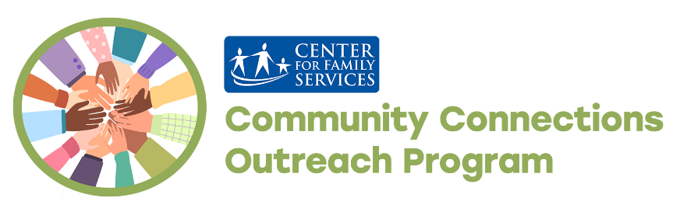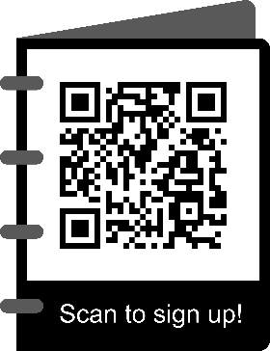 **Community Connections Outreach** 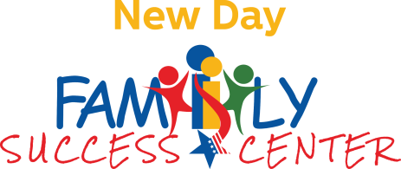

1324 Little Gloucester Road

 Blackwood, New Jersey 08021

**(609) 471-7004**

Community.Connections1324@gmail.com

Pre-Registration Requested for Events



**Community Connections Outreach – Gloucester Township**

**\*All services at our center such as printing, copying, faxing, & laptops are available with an appointment. We have masks available on-site if you would like to wear one.**

**\*Virtual resume & cover letter review is available via email. Email documents to community.connections1324@gmail.com\***

|  |  |  |  |  |  |  |
| --- | --- | --- | --- | --- | --- | --- |
| **Monday**    **9am-5pm** | **Tuesday**  **9am-5pm** | **Wednesday**  **11am-7pm** | **Thursday**  **9am-5pm** | **Friday**  **9am-5pm** | | **Saturday** |
| **1** | **2** | **3 Celebrate**  **Mother’s Day With Make and Take Mocktail Mimosas**  **4:30-6:30pm** | **4** | **5**  **Cinco de Mayo Party**  **2:30-4:30pm** | **6** | |
| **8**  **Low-Impact Pilates**  **11am-12pm** | **9** | **10**  **Affordable Health Insurance Enrollment**  **1-4:30pm** | **11**  **Join our Kiwanis friends for their annual kickoff!** | **12**  **Mother’s Day Make and Take Crafts and Gifts**  **2:30-4:30pm** | | **13** |
| **15**  **Chit Chat and Relax**  **3-4pm** | **16** | **17**  **Chat and Chew: Community Advisory Board and Food**  **4:30-6:30pm** | **18** | **19**  **Heritage Trivia Game**  **2-4pm** | | **20** |
| **22**  **Meditation Monday**  **2-3pm** | **23** | **24**  **Cooking With Brian**  **5:30-7pm** | **25** | **26**  **Bingo**  **2-4pm** | | **27** |
| **29**  **Closed for Memorial Day** | **30** | **31**  **May Birthday Celebration**  **4:30-6:30pm** |  | **All hybrid and virtual events can be viewed via a Zoom or Google Meet link upon registering on Eventbrite.** | | |

**\*Check out the back of the calendar for more info\***

|  |
| --- |
| ***A Program of Center for Family Services Funded Through the Community Planning and Advocacy Council.*** |

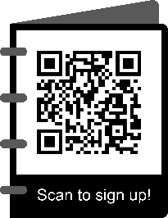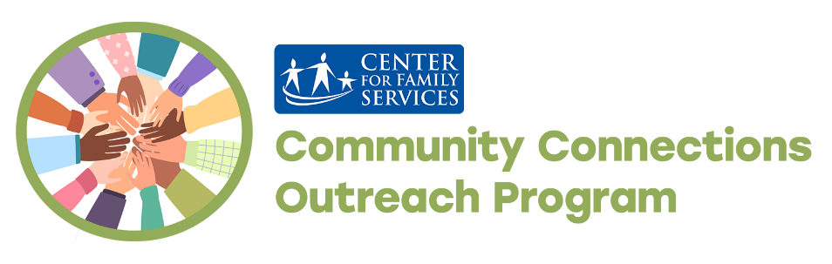

Scan the QR code to sign up for our events!

**May 2023**

**Event Information Below**

|  |  |
| --- | --- |
| **Center Highlights**  **Affordable Health Insurance Enrollment-** Call or email us to set up an appointment to talk with a healthcare expert from our friends at Navigator Exchange Program. One of their members will be at Community Connections on the second Wednesday of each month to offer free, impartial, and confidential one-on-one assistance.  **Community Advisory Board**- We need your feedback! Do you have ideas regarding calendar activities and community resources? Do you want your voice to be heard? We would love to see you at our monthly Community Advisory Board meeting. This is more of a discussion and a time to hang out, compared to what might come to mind if you think, “board meeting.” Check it out! | **Family Activities**  **Cinco de Mayo Party-** Come celebrate culture, cuisine, and heritage with us!  **Mother’s Day Make and Take Gifts and Crafts-** There are a lot of reasons to celebrate the moms and ladies in our lives! Bring the whole family and make fun gifts for Mom. Or, if you’re a bit busy, you can swing by and pick up the supplies and instructions for a gift or craft as well!  **May Birthday Celebration-** Does a member of your household have a May birthday? We want to celebrate with you! Bring your family and friends for an afternoon full of fun and sweet treats! |
| **Employment and Volunteering**  **Employment Series-** Need help seeking employment? Feel free to reach out to us to make an appointment.  **Volunteer Opportunities –** Are youlooking to contribute to the development of your community? Have a skill you want to share? You can help by hosting an event. You can make a difference for our families! | **Always Available**  **Community Advisory Chat-** Any events that you want to see at the center? Have ideas that you think families would enjoy? Have suggestions about past events to make it better? Want to give us feedback? Come in, call, or email us any time! We would love to hear from you!  **Resources-** We have a variety of information, referrals, and linkages. Give us a call! |



